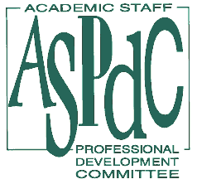2007-2008

ACADEMIC

STAFF

AWARDS

Call for Nominations
Deadline: Sunday, March 30, 2008

The Academic Staff Professional Development Committee (ASPDC) requests your nominations for the 2007-2008 Academic Staff Awards. The awards will be presented at the Annual Awards luncheon in the Spring.

There are three nomination categories: Professional Achievement, Distinguished Service, and Outstanding Contributor.

- Professional Achievement Award: is conferred upon the recipient for demonstrated leadership, significant accomplishment(s) in professional organizations and presentations and/or publications.

- Distinguished Service Award: is conferred upon the recipient for significant service to students, the university, department and/or community organizations, committees and/or other service beyond job responsibilities.

- Outstanding Contributor Award: is conferred upon the recipient(s) for significant accomplishments during the previous three years, emerging leadership and/or scholarship. This award is dedicated for recognizing junior academic staff (less than seven years of university service).

The Nomination Form is available at http://www.aspdc.wayne.edu/awards/index-awards.htm and through the “Academic Staff” Pipeline portal. Self-nominations are welcome. We encourage multiple nominations from units and more than one person may be nominated for each award. A separate form is to be used for each nomination.

All completed award nominations must be submitted not later than Sunday, March 30, 2008, to Jane Helinski, 7-0831, aa9963@wayne.edu or Terry Kerby, 7-2987, ab1315@wayne.edu. Electronic submission in Word, PDF or Text is preferred.

